**GDB USAGE**

**JAIN RAJAT 3035453684, TALWAR PRANAV 3035435462**

**Generating the file for debug mode:**



The resulting file is called a.out, which is used in gdb to start the debug process.

**Executing the code in debug mode:**

* First, using break to break the program during execution.
* Subsequently using the step command to execute the code line by line or using continue to continue execution till the next break point.
* Using p or print to display the value of the variables during execution.

Variables Under Consideration:

* **command**: string which stores the command given by the user.
* **pid**: to store the status of the child process
* **CommandLog**: STL Vector Container which stores elements of the type Command a user defined class to store the names of the command issued and their corresponding execution times.

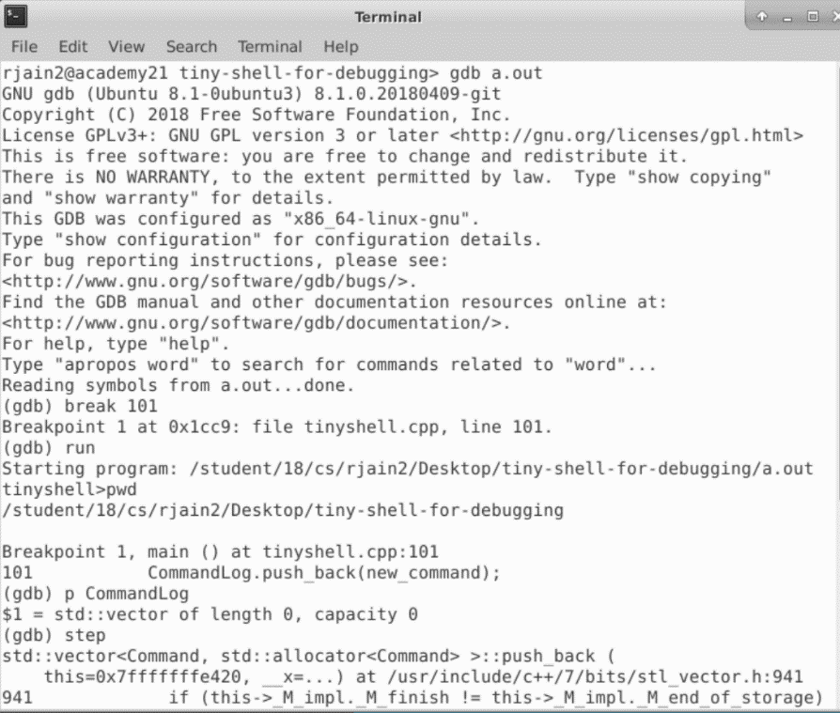

… many **step**s later…

